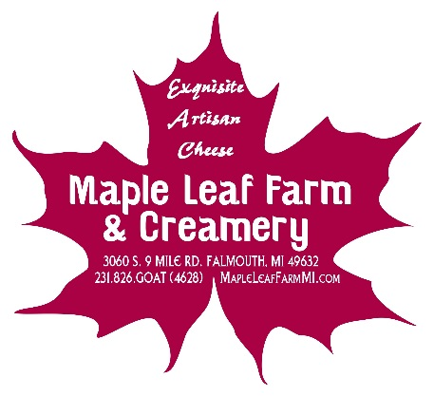
Maple Leaf Farm & Creamery LLC
Jeanne Suggate
3060 S. 9 Mile Rd.
Falmouth, MI 49632
231-826-4628
migoatlady@yahoo.com

2026 CSA / Membership Application
To be enrolled in our 2026 CSA program, please complete, and return the form below.

** We will accept a minimum of 50% of the total payment due at the time of the signing of the contract. The balance needs to be paid in full prior to April 1st, 2026 . Understand that Payments are nonrefundable**

Name:___________________________________________
Address:_________________________________________
City:________________ State:__________ Zip: _________
Phone:___________________________________________
E-Mail:___________________________________________

I, ___________________________ commit to a membership of Maple Leaf Farm and Creamery CSA program for the 2026 growing season. I understand that the Vegetable CSA program will start sometime near the end of June 2026 and continue for a minimum of 10 consecutive weeks. I understand that I will receive a share in each week’s harvest of vegetables and one dozen eggs. I understand that a Half share is identical to the Full share program, except in quantity. A Half share will receive 50% of a full share each week. I also understand that the variety of vegetables that I receive depends on the growing conditions that will vary from season to season and that the risks and benefits of the harvest are shared. I understand that this contract binds me to pick up my share from the farm or designated pick-up location to be determined.

Please mark rather you are choosing a full share or a half share!
_____Full Share ~ Two bags of a variety of in season vegetables and one dozen eggs each week. Honey once throughout the season. $375
_____ Half Share ~ One bag of a variety of in season vegetables and one dozen eggs each week . Honey once throughout the season. $250

~ADD ONS~
Variety Pack Cheese $6.50/week - Bi-Weekly($32.50)____ Weekly($65.00)____
Artisan Bread $7.00/week - Bi-Weekly($35.00)____ Weekly($70.00)____(dependent on overall CSA member interest)
Flower Arrangement - $10/week - Bi-Weekly($50.00)__ Weekly($100.00)____
Cookies - $6.50/week - Bi-Weekly($32.50)____ Weekly($65.00)____
Fruit Share - $6.00/week - Weekly($60.00)____ Will include whatever is in season & available!

Member Signature___________________________________________________
Total Cost________________ Payment Included_________________

Balance Due Before April 1, 2026 ____________

**We can also accept debit/credit card payments, contact us for card payments. Receipts for all payments will be emailed.
Our Guarantee
There are a number of risks involved with raising livestock and growing vegetables. We are not able to offer any money back guarantee because many of these risks are out of the farms control. We will do everything possible to make this a positive experience for you and your family. In the event of some crop failures, the farm will do all it can to extend the growing season and may add additional weeks of harvest to the schedule without any further cost to our members. We feel this plan of extra production beyond the projected needs for our CSA is a very good insurance plan for our members and for the farm’s success.

